**HO CHI MINH CITY UNIVERSITY OF**

**FOREIGN LANGUAGES AND INFORMATION TECHNOLOGY**

**FACULTY OF FOREIGN LANGUAGES**

------🙝🕮🙟------

**RESEARCH PAPER**

**TOPIC: AN INVESTIGATION INTO THE DIFFICULTIES OF OBTAINING FLUENCY AND ACCURACY IN TRANSLATION SUBJECTS AMONG ENGLISH TRANSLATION AND INTERPRETATION STUDENTS AT HUFLIT**

Supervisor: Nguyễn Minh Thư

Student: Phạm Trần Mẫn Nghi

Student’s number: 22DH713339

Class: BA2205

Major: English Language Studies

**Ho Chi Minh City, April 4th, 2025**

Contents

ABSTRACT 3

CHAPTER 1: INTRODUCTION 4

1.1. CONTEXT OF RESEARCH 4

1.2. AIM OF STUDY 5

1.3. RESEARCH QUESTION 5

CHAPTER 2: LITERATURE REVIEW 5

2.1. Obstacles in obtaining fluency and accuracy 6

2.1.1. Linguistic differences 6

2.1.2. Idioms and Proverbs 7

2.1.3. Balancing fluency and accuracy 8

2.2. Improving solutions for HUFLIT educators and students 8

2.2.1. Educators 8

2.2.2. Students 9

CHAPTER 3: RESEARCH METHOD 9

3.1. Quantitative method 9

3.2. Participants 10

3.3. Instruments for data collection 10

3.4. Ethical consideration 10

CHAPTER 4: RESEARCH FINDINGS 10

4.1. Difficulties in translation 10

4.2. Improvement methods 15

CHAPTER 5: RESEARCH DISCUSSION 17

CHAPTER 6: CONCLUSION AND RECOMMENDATION 19

REFERENCES 21

APPENDIX 22

# ABSTRACT

The key purpose of this research is to investigate the challenges faced by HUFLIT English translation and interpretation students in translation subjects, specifically in obtaining fluency and accuracy. Additionally, offering primary information and potential solutions to improve the curriculum for HUFLIT educators and crucial skill-developing methods for students. The data was collected using the quantitative method based on the students’ opinions. The survey was conducted on 84 HUFLIT English major students concerning translating difficulties and improving recommendations. The findings display that common obstacles students frequently struggle with are linguistic aspects, figurative expressions (idioms and proverbs), and fluency-accuracy balance. Regarding curriculum development, task-based learning methods and cultural learning are recommended. Furthermore, HUFLIT students are encouraged to engage with practical texts, update their knowledge in various fields, and seek the lecturer’s feedback to improve their translation skills. The survey also gathers students’ opinions concerning skill-developing methods, in which regular practice and diverse topic exploration are suggested as highly effective approaches. The study has three notable limitations: personal observations, time restrictions, and lack of experience in providing thorough teaching methods. Future research is suggested to concentrate on specific teaching approaches for the HUFLIT curriculum.

# CHAPTER 1: INTRODUCTION

## CONTEXT OF RESEARCH

With the rise of global trade and communication, where people demand more knowledge about humans and cultural differences, English is the primary tool for communicating and bridging the language barrier. Since then, English has been brought into daily life, school curriculum, and highly specialized sectors. As a result, translation evidently became an indispensable field in adapting English to an approachable yet accurate equivalence in the target language. Translating is a specialized major that requires both linguistic and cultural proficiency from learners, including having a profound understanding of various fields such as art, politics, economics… Mastering translating is a common challenge among language major students, especially those not using English as their native language. Moreover, due to the differences in culture and the complex nature of each nation’s language, English translation might become vague or unable to fully express certain words and nuances.

In order to successfully adapt English to Vietnamese or vice versa, students need to ensure both fluency and accuracy in sentences. Accuracy in translation consists of conveying the author's implication – literal meaning, figurative meaning, non-existent notions, or inaccurate concepts in the target language, without adding or changing the translation based on the translator's perspective. On the other hand, referred to as naturalness and readability, fluency helps the translated text sound smooth and simultaneously appropriate to the target language norms. Nevertheless, overconcentrating on one side may lead to a lack of the other. Therefore, language major students must have a thorough knowledge of both language structure, meaning, and application to perform a good translation.

Concerning HUFLIT, one of the prestigious universities for English language majors, translation is considered the most challenging subject among translation and interpretation students. By facing the same difficulties – significant differences in culture and language structure, many HUFLIT students also struggle to translate between Vietnamese and English. Therefore, this research will focus on investigating obstacles that English translation and interpretation students at HUFLIT  encounter when obtaining fluency and accuracy in translation subjects.

## AIM OF STUDY

This study aims to explore the specific challenges HUFLIT English translation and interpretation students face in obtaining both fluency and accuracy in their translation subjects. By searching for the difficulties and their causes, the research will provide more information and possible solutions, contributing to improving the curriculum of translation subjects for HUFLIT’s educators and supporting English language major students to perform better in their translation studies.

## RESEARCH QUESTION

1. What factors obstruct English language major students at HUFLIT in obtaining fluency and accuracy in translation subjects?
2. What solutions can HUFLIT educators and students apply to overcome these difficulties and improve the learning methods for translation subjects?

# CHAPTER 2: LITERATURE REVIEW

A good translation must include the two most significant and necessary elements which are fluency and accuracy. Both aspects are vital for translating but serve different purposes and must be used appropriately. While accuracy ensures faithfulness to the source language, fluency aims for flexibility and the target language’s norms. Fluency or accuracy will be prioritized depending on the text's nature and target audiences. However, obtaining and utilizing both components suitably is a challenge for students. Therefore, the researcher decided to investigate the difficulties of obtaining fluency and accuracy in translation subjects among English translation and interpretation students at HUFLIT to improve the learning method effectively.

## Obstacles in obtaining fluency and accuracy

### Linguistic differences

Even though sharing the same Latin alphabet, according to Tichelaar (2002), English belongs to the Germanic language family, while Vietnamese belongs to the Austro-Asiatic language family, leading to remarkable differences in the linguistic aspect. Comparing the two languages, English is strictly bound by the sentence structure, while Vietnamese is more flexible in its grammar rules, which causes significant obstacles in translating.

#### Tenses and irregular verbs

English grammar mainly focuses on tenses and verb conjugation; meanwhile, Vietnamese belongs to the isolating language group, which does not combine root words with suffixes to express grammatical forms like English. This feature makes Vietnamese grammar more flexible in using tenses and verbs. However, translating from Vietnamese to English is a challenge for students. The translator must carefully consider the time that occurred to ensure accuracy in the source language and appropriately adjust the target language.

#### Preposition and auxiliary verb

Prepositions and auxiliary verbs in English have fixed roles and must be used with the correct pronouns. In contrast, Vietnamese prepositions are sometimes less complex and even omitted. Moreover, there are no auxiliary verbs in Vietnamese. As a result, translators should also concentrate on the differences while translating to avoid grammar mistakes.

#### Non-equivalent terms and vocabulary

Non-existing terms in both languages also significantly affect the translation process. Translators must convey the author’s message and simultaneously address the language appropriately according to the target language’s word structure and culture. Non-equivalent vocabulary is sometimes translated descriptively, which may reduce the fluency of the text, or non-existent vocabulary is translated using the closest possible alternative, which may result in a loss of accuracy in translation.

#### Cultural Nuances

Vietnamese and English originate from Eastern and Western countries, with entirely different cultures, lifestyles, and mindsets. Therefore, there are also distinctive ways to express linguistic and convey emotions through vocabulary. Furthermore, Vietnamese is an isolating language, using functional words and intonations to enhance expressive nuances. For instance, function words like "nhé," "nhỉ," "ạ,"... are usually added to a sentence to express emotions or manners. On the contrary, English mainly uses intonations to display feelings. Because of the significant differences, maintaining the same tone when translating Vietnamese to English might become challenging.

### Idioms and Proverbs

Idioms and Proverbs are phrases that carry figurative meanings and reflect the conceptions and beliefs of a linguistic community. Those values may be valid and widely accepted in an English-speaking community but may not be appropriate in Vietnamese. Take the idiom “as strong as a horse” as an example. This comparison is not standard in Vietnam; a “horse” is not considered the strongest animal in Vietnamese culture but rather a “buffalo.” When describing the strength, Vietnamese usually use the buffalo, which originated from their agricultural culture. As a result, it is not easy to find accurate expressions when translating idioms and proverbs. Translators must have a profound knowledge of both cultures to make a good translation that conveys the original message but is still suitable in the target language.

### Balancing fluency and accuracy

It is said that a translator cannot aim for both accuracy and fluency simultaneously since the most accurate translations are not always the most fluent (Lim et al., 2024). Although both aspects are essential for translating, they have different functions and should be handled appropriately in specific texts. Previously, most high school curriculum used the Grammar-Translation method – learning the grammatical rules and applying them to the word-for-word translation. This method has an influence on the student’s translating mindset and their adapting skill. When integrating a practical translation, especially in literary translation that requires the readability of the translation, aiming at the target language, students need to focus more on the fluency aspect. On the contrary, legal or economic works require the accuracy of the translation and focus on the source language. As a result, translation students have to depend on their skills and determine which text should fluency or accuracy be prioritized. As well as learning specific writing styles and tones in both languages to conduct a good translation.

## Improving solutions for HUFLIT educators and students

### Educators

#### Task-base learning

Task-based learning (TBL) is a language learning method based on doing familiar tasks such as real-life practice and learning through activities. The TBL method was first designed and developed by N.S. Prabhu in Bangalore, southern India. In a study by Prabhu (1987), he believed that rather than focusing on the language, students will perform more effectively when focusing on the task they are doing. In translation, TBL allows students to approach real-world translation exercises such as subtitling movies and translating news, legal or literary. This approach will ensure that students develop their fluency and accuracy efficiently while translating a practical text. As for HUFLIT educators, providing TBL exercises and assisting students with real-life knowledge may help them enhance their translating performance.

#### Cultural learning

Achieving fluency and accuracy requires profoundly considering both languages, especially the cultural aspects. Language cannot be separated from culture since language is one of the cultural manifestations (Djamereng, 2018). Even a proper grammatical translation can be perceived as unnatural or vague if the cultural understanding is misinterpreted. Evidently, language major students not only translate the word but also transfer the cultural implications beyond the linguistic aspect. It will be necessary for HUFLIT to offer more cultural-related workshops and courses, giving students a chance to learn about the influence of cultural differences on translation. Thus, students can effectively apply the knowledge to their translation tasks.

### Students

Translating requires various knowledge and constant updates from students. Integrating with practical texts such as legal, economic, or literature is a key factor in achieving fluency and accuracy. Additionally, expanding more knowledge concerning different fields and specializations will help students build a solid basis for their translation work. Furthermore, seeking the lecturer's advice and peer review also helps students reflect on and improve their weaknesses. By combining these strategies, students can develop crucial skills to produce a fluent and accurate translation.

# CHAPTER 3: RESEARCH METHOD



## Quantitative method

Quantitative research is a method that tests objective theories by examining the relationship among variables (Creswell, 2003); it “explains phenomena by collecting numerical data that are analyzed using mathematically based methods” (Aliaga & Gunderson, 2002). In other words, quantifying data collection and analysis. Quantitative research data are often gathered in a large scope using a questionnaire. The main goal of this design is to investigate the difficulties in obtaining fluency and accuracy in translation subjects among English translation and interpretation students at HUFLIT. 84 English language students were given an online questionnaire through Google form via social media sites such as Facebook and Zalo to address the research objectives. The maximum duration is two weeks.

## Participants

84 English-majored students in the Department of Foreign Language at HUFLIT, who have gone through several translation courses, participated in the survey.

## Instruments for data collection

Online questionnaire (Google form)

## Ethical consideration

The research follows ethical principles to ensure the rights and safety of all participants. Before conducting the survey, participants will be informed about the purpose of the research and will give their consent willingly without any pressure. All the participants' information and data will be kept private and used only for research purposes.

# CHAPTER 4: RESEARCH FINDINGS



## Difficulties in translation

**Figure 1. Average scores of students in translation subjects**

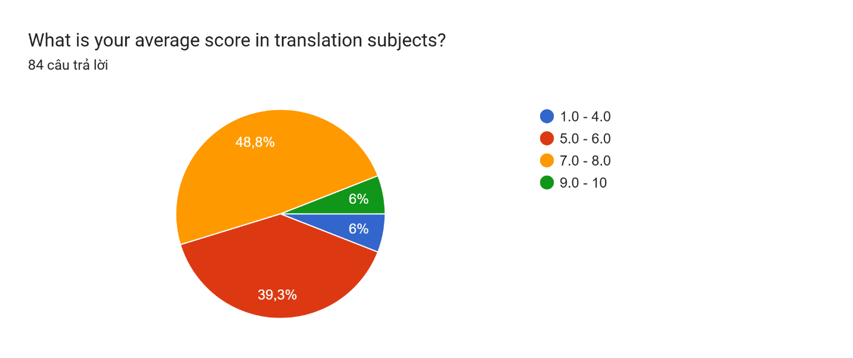

This figure presents students' average scores, reflecting their academic performance in translation subjects, with most scoring between 5.0 and 8.0.

**Figure 2. Challenge aspects in translation**

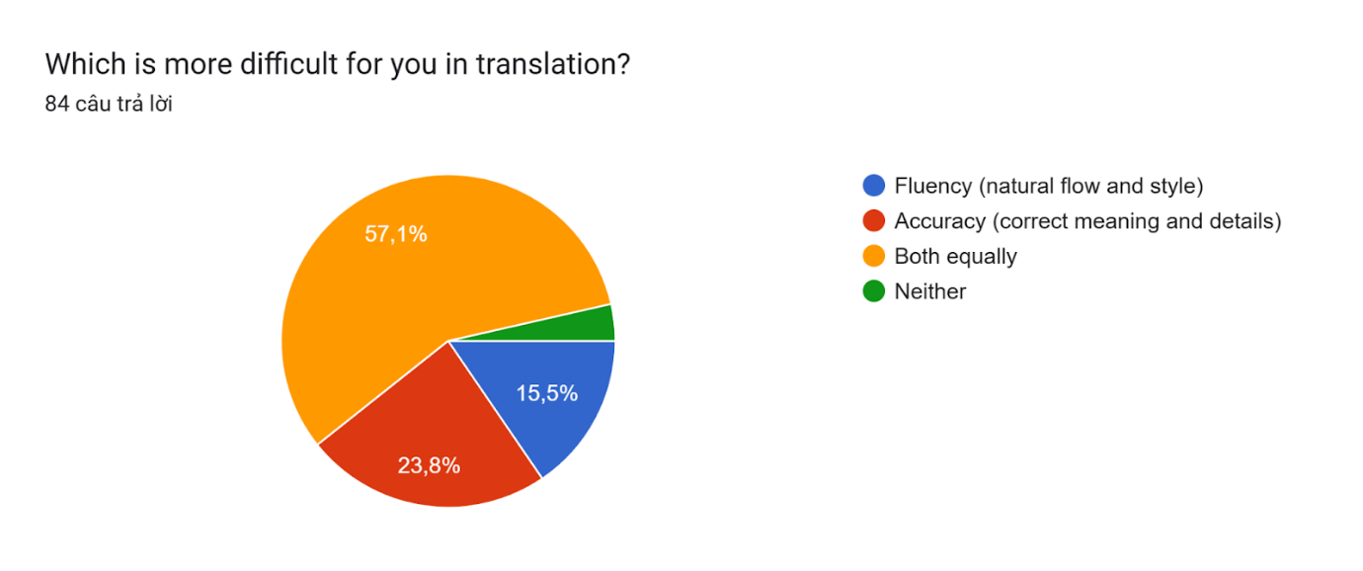

Figure 2 illustrates the aspect that most students found challenging in translation, making both components equally tricky.

**Figure 3. Frequency of struggle in maintaining fluency in complex texts**

**Biểu đồ câu trả lời của biểu mẫu. Tên câu hỏi: How often do you struggle to maintain fluency in complex texts?  
. Số lượng câu trả lời: 84 câu trả lời.**

**Figure 4. Frequency of struggle in maintaining accuracy in complex texts**

**Biểu đồ câu trả lời của biểu mẫu. Tên câu hỏi: How often do you struggle to maintain accuracy in complex texts?  
. Số lượng câu trả lời: 84 câu trả lời.**

A notable trend was observed in Figure 3 and Figure 4, showing how often participants face difficulties maintaining fluency and accuracy in complex texts. Most responses are “Often,” indicating students frequently struggle to conduct a fluent and accurate translation.

**Figure 5. Difficult part in translation subjects**

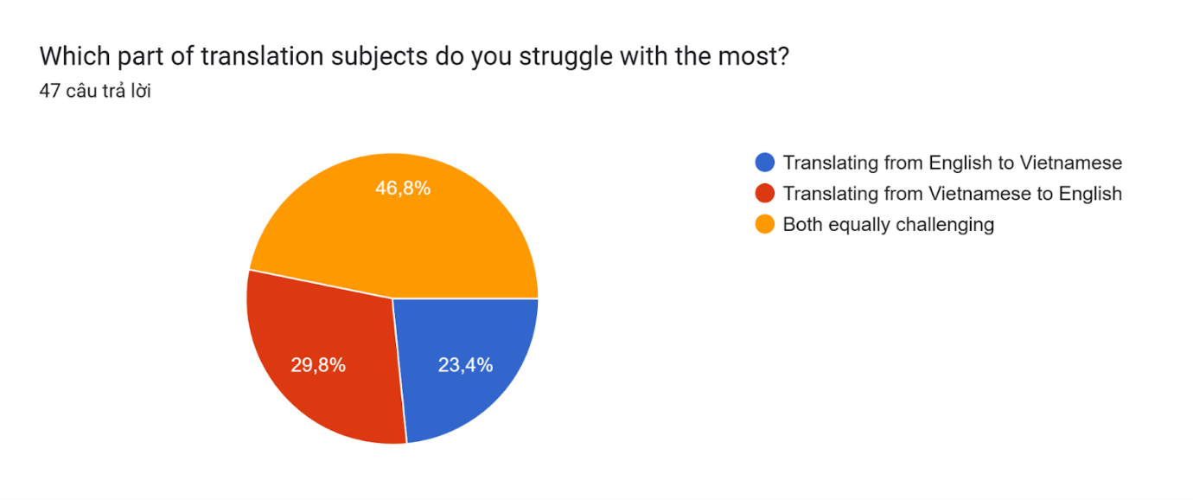

The data reveals that a majority of participants struggled with both Vietnamese and English translation.

**Figure 6. Common difficulties in obtaining fluency and accuracy in translation**

**Biểu đồ câu trả lời của biểu mẫu. Tên câu hỏi: Which of the following aspects do you find challenging in obtaining fluency and accuracy in translation?  
. Số lượng câu trả lời: 84 câu trả lời.**

This figure highlights the three common challenges in translation that participants often face while obtaining fluency and accuracy in translation, which are “Dealing with linguistic differences,” “Maintaining naturalness without changing the original message,” and “Adapting idioms and proverbs.”

**Figure 7. Difficulty ratings of linguistic differences**

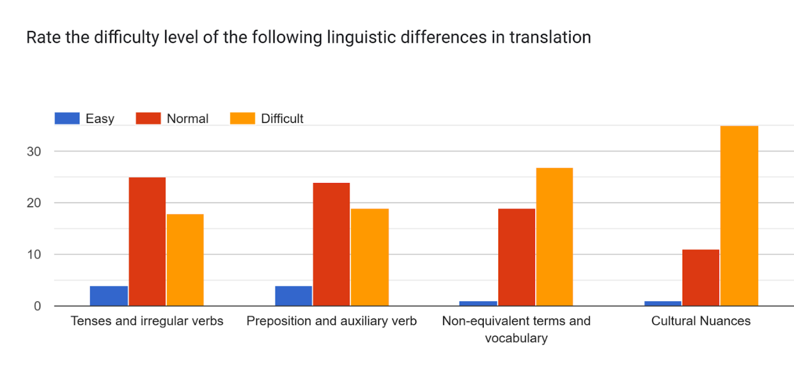

Figure 7 displays the evaluation of the difficulty level of linguistic differences in translation. Interestingly, there was a significant increase in “Non-equivalent terms and vocabulary” and “Cultural Nuances,” which were chosen as the most difficult to adapt from English to Vietnamese and vice versa.

## Improvement methods

**Figure 8. Preferred supporting method in translation courses**

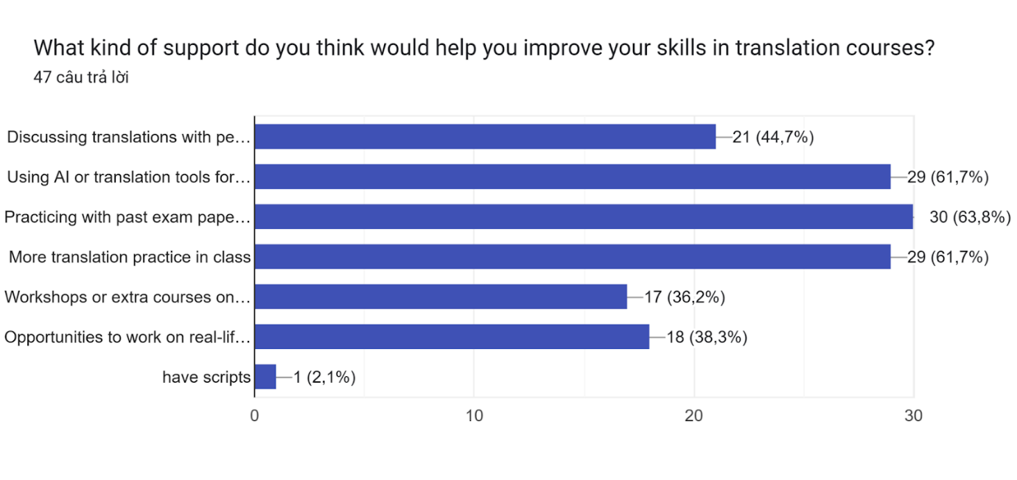

The figure indicates different types of support participants think would help them improve their translation courses. “Practicing with past exam papers or assignments” accounted for the most significant proportion of the best improving methods, besides “Using AI or translation tools for assistance” and “More translation practice in class” are also believed to be good ways to improve necessary skills in translation courses.

**Figure 9. Preferred improving method among students**

**Biểu đồ câu trả lời của biểu mẫu. Tên câu hỏi: Which method would you choose to improve your translation fluency and accuracy on your own?
. Số lượng câu trả lời: 84 câu trả lời.**

The results in Figure 9 demonstrate the distinguished methods for improving fluency and accuracy among students. Leading the chart is “Expand knowledge,” followed by “Integrate more practical translations,” with “Cultural and contextual learning” in the third place.

# CHAPTER 5: RESEARCH DISCUSSION

The research findings focus on addressing the difficulties faced by HUFLIT students in translation and improving methods that can be used to assist both educators and students. As proven in the findings, the average score of students ranges from 5.0 to 8.0, and the frequency of struggle in conducting a good translation that includes both fluency and accuracy in complex texts indicates that translation subjects are challenging for the students. It is not easy to obtain a higher mark. Most of them also agree that fluency and accuracy are equally challenging and apparently on the same difficulty level, either when translating from English to Vietnamese or vice versa.

Particularly, HUFLIT students find “Dealing with linguistic differences” is the most challenging aspect of obtaining fluency and accuracy in translation (73,8%). This result is consistent with previous studies by Tichelaar (2002). She mentioned that English and Vietnamese come from different language families, and it is difficult for any language learner in general, especially HUFLIT English students, to efficiently handle these distinguishable and unfamiliar structures in their native language. Among the four linguistic differences mentioned in the literature review, the result is a stark contrast with the research when a significant part of HUFLIT English students rate identifying and translating “Tenses and irregular verbs” and “Prepositions and auxiliary verbs” as “Normal,” which means they rarely struggle with these differences. Meanwhile, many HUFLIT English students agree that “Non-equivalent terms and vocabulary” and “Cultural nuances” are the hardest to adapt. Considering the historical and cultural context of the two languages, English was shaped by many Western cultures, and they emphasized individualism and directness in speaking. Meanwhile, the Vietnamese language was heavily influenced by the Chinese culture, which focused on indirect communication and honorific expressions. A translator must carefully consider such differences to deliver the same expression level and appropriateness in the target language.

The second most chosen answer is “Maintaining the naturalness without changing the original message” (58,3%). This result aligned with the study of Lim et al. (2024), which suggested that fluency and accuracy could not be simultaneously maximized in one translation. Assuming a legal document, in which accuracy should be prioritized in order to be faithful to the source language. On the contrary, literary work focuses more on fluency and equivalences, aiming for readability in the target language. As a result, HUFLIT English students might face the same difficulty while trying to balance both aspects without leaving one behind.

Lastly, the third-highest proportion is adapting idioms and proverbs (35,7%). Idioms and proverbs carry the culture and history of one language. Most idioms and proverbs are deeply rooted in a country’s tradition and culture, which makes it hard to capture the exact expression in another language. A direct translation might not convey the intended meaning lying beneath the word; therefore, the lack of cultural knowledge can lead to misinterpretation and misunderstanding while translating.

Regarding improving methods, most students select “Practicing with past exam papers and assignments” as the most efficient way to enhance their overall translation skills. By reflecting on their fault, they can avoid making the same mistake on the next assignment and develop their skills based on the lecturer’s comments. Subsequently, both methods received the same second-highest number of votes are, “More translation practice in class” and “Using AI or translation tools for assistance”. Even though using AI for translation works has been controversial since the rise of AI-supporting tools developed, the researcher believes that AI should be used as an academic assistant, especially in translation. Aside from translating, AI tools such as Grammarly are specialized for grammar learning, and ChatGPT can collect data immediately. Based on AI's benefits, it should be considered a new teaching and learning method as long as students learn how to use AI tools properly.

For self-improving methods, expanding knowledge accounts for the most significant percentage among HUFLIT English students. Apart from the essential skills for translation, expanding general knowledge is also an essential component that contributes to a fluent and accurate translation. The more knowledge a translator has, the more comprehensive the translation will be.

Followed by “Integrating more practical translations” as the second-most chosen answer. The result aligns with Pradhu's study (1987), which states that language learners will perform better when integrated with pragmatic activities; the same goes for HUFLIT English students. Most participants also agree that using real-world economic, legal, or literature documents to practice is an excellent approach to enhancing their knowledge and skills simultaneously.

Finally, cultural learning is also voted as an effective method for improving translation skills. Having a profound understanding of English and Vietnamese culture, customs, and traditions will enhance the readability of a translation, and therefore, a translator can produce a better performance.

# CHAPTER 6: CONCLUSION AND RECOMMENDATION

In summary, the two primary goals of this research are to discover the challenging causes of obtaining fluency and accuracy in translation subjects among English translation and interpretation students at HUFLIT. In addition, the research also provides HUFLIT educators with valuable findings, possible solutions for future curriculum advancement, and necessary skills-improving methods for HUFLIT students. Apparently, the research shows that a majority of HUFLIT English translation and interpretation students are facing difficulties in conducting a good translation, especially achieving fluency and accuracy due to several common limitations, such as dealing with linguistics differences, adapting idioms and proverbs, and finally balancing fluency and accuracy in translation works. As for HUFLIT educators, the researcher suggests applying the task-based learning method to the curriculum. Besides, cultural learning is another potential teaching approach for enhancing students’ specialized skills. Furthermore, HUFLIT students are recommended to practice with pragmatic texts and expand their general knowledge independently, aside from learning in school. Then, asking for the lecturer's opinion and peer review on their translation works is the most efficient way to reflect on and improve their overall skills. Moreover, the researcher received many constructive suggestions from HUFLIT students for conducting a fluent and accurate translation; most participants proposed that translating diverse topics and practicing regularly would be an effective strategy. Although contributing essential findings to the relevant study area, the research still has some considerable limitations. The first limitation is that the research was conducted mainly on the researcher's personal observation; therefore, the study lacks objectivity and does not engage much with previous literature in the same area. Time restriction is the second limitation of the research, resulting in only 84 HUFLIT students participating in the survey in the span of two weeks. Lastly, the researcher could not provide a thorough teaching method for HUFLIT educators due to the lack of expertise and experience in teaching. For these reasons, future research can concentrate on particular teaching methods and detailed lesson plans that can be applied to the HUFLIT curriculum.

# REFERENCES

Tichelaar, T. (2002, August). *Toponymy and language*. UNSD. https://unstats.un.org/unsd/geoinfo/ungegn/docs/_data_icacourses/_HtmlModules/_Documents/D09/documents/D09-01_Tichelaar.pdf

Lim, Z. W., Vylomova, E., Cohn, T., & Kemp, C. (2024, June 10). *Simpson’s Paradox and the Accuracy-Fluency Tradeoff in Translation*. arXiv. <https://arxiv.org/pdf/2402.12690>

Prabhu, N. S. (1987). *Second Language Pedagogy*. Oxford University Press. <https://gustavorubinoernesto.com/wp-content/uploads/2020/09/N.S.-Prabh-Second-Language-Pedagogy.pdf>

Djamereng, J. (2018). IDEAS: Journal on English Language Teaching and Learning, Linguistics and Literature. *TRANSLATION STUDY: HOW CRUCIAL IS CULTURAL KNOWLEDGE FOR STUDENTS AS THE TRANSLATORS?*, *Volume 6, Number 2*, 126–138. https://doi.org/10.24256/ideas.v6i2.519

Creswell, J. (2003). *RESEARCH DESIGN Qualitative, Quantitative. and Mixed Methods Approaches*. Cumming School of Medicine. <https://cumming.ucalgary.ca/sites/default/files/teams/82/communications/Creswell%202003%20-%20Research%20Design%20-%20Qualitative%2C%20Quantitative%20and%20Mixed%20Methods.pdf>

Apuke, D. (2017). QUANTITATIVE RESEARCH METHODS A SYNOPSIS APPROACH. *Arabian Journal of Business and Management Review (Kuwait Chapter)*, *Volume 6, Number 10*, 40–47. <https://doi.org/10.12816/0040336>

# APPENDIX

1. **What is your main major?**

* Translation & Interpretation
* Office Administration
* English Language Teaching
* Business English
* English – Chinese Bilingual Studies
* English Logistic

1. **What is your average score in translation subjects?**
   * 1.0 – 4.0
   * 5.0 – 6.0
   * 7.0 – 8.0
   * 9.0 – 10
2. **Which is more difficult for you in translation?**
   * Fluency (natural flow and style)
   * Accuracy (correct meaning and details)
   * Both equally
   * Neither
3. **How often do you struggle to maintain fluency in complex texts?**
   * Always
   * Often
   * Sometimes
   * Rarely
   * Never
4. **How often do you struggle to maintain accuracy in complex texts?**
   * Always
   * Often
   * Sometimes
   * Rarely
   * Never
5. **How confident are you in your ability to produce a fluent and accurate translation?**

(Rate from 1 to 5, 1 is very easy, and 5 is very difficult)

1. **Which part of translation subjects do you struggle with the most?**
   * Translating from English to Vietnamese
   * Translating from Vietnamese to English
   * Both equally challenging
2. **Which type of text is the hardest to translate fluently and accurately?**
   * Technical (manuals, scientific papers)
   * Legal (contracts, laws)
   * Marketing (advertisements, social media)
   * Literary (stories, novels)
   * Other options
3. **Which of the following aspects do you find challenging in obtaining fluency and accuracy in translation?**
   * Dealing with linguistic differences (grammar, word structure, nuances....)
   * Adapting idioms and proverbs
   * Maintaining the naturalness without changing the original message
   * Translating specialized terminology (e.g., medical, legal, technical)
   * Misinterpreting cultural references
4. **Rate the difficulty level of the following linguistic differences in translation**

**ROW**  **COLUMN**

* + Tenses and irregular verbs Easy
  + Preposition and auxiliary verb Normal
  + Non-equivalent terms and vocabulary Difficult
  + Cultural Nuances

1. **How effective are the teaching methods used in translation courses at HUFLIT?**
   * Very effective
   * Effective
   * Moderately effective
   * Slightly effective
   * Not effective at all
2. **How often do you practice translating texts outside of class assignments?**
   * Everyday
   * A few times a week
   * Once a week
   * Rarely
   * Never
3. **What kind of support do you think would help you improve your skills in translation courses?**
   * Discussing translations with peers and teachers
   * Using AI or translation tools for assistance
   * Practicing with past exam papers or assignments
   * More translation practice in class
   * Workshops or extra courses on translation techniques
   * Opportunities to work on real-life translation projects
   * Other options
4. **Which method would you choose to improve your translation fluency and accuracy on your own?**
   * Integrate more practical translation (news, legal documents, literature)
   * Practicing translation daily
   * Studying grammar and syntax in both languages
   * Cultural and contextual learning
   * Expand knowledge (vocabulary, expression, specialized topic)
   * Reading and analyzing high-quality translations
   * Watching bilingual content (movies, videos, etc.)
   * Other options
5. **Do you have any recommendations for improving fluency and accuracy in the translation teaching methods at HUFLIT?**